Bidbury Infant

We can hardly believe we have been back at school for over a month. It has been fantastic to have all the children back where they should be and to have a bustling school full of fabulous learners. Everyone has come back with a smile and buckets of enthusiasm.

Welcome to Bidbury!
We have enjoyed getting to know all of our new YR children. We have also welcomed Mrs Quehan as Assistant Head, Mrs Keegan as our new Admin Officer and Mrs Southall as a Learning Support Assistant. They are already an asset to the team.
COVID
COVID seems to invade every part of what we do but our prevention measures continue to be used and are effective. Long may we remain COVID free. Thank you to all those who are wearing masks as we have requested. And also thank you for trying to stick to the arrival and collection times – I know this is difficult for us all but we can get through it together.

Remote Learning
Thank you to all those who completed the Remote Learning Questionnaire. If your child is off because someone in your household is isolating please let us know. We will provide you with home remote learning and the means to send work back to us for the teacher to comment on. We will shortly send an email about Edmodo which is a secure learning network
for teachers, children and
parents. It provides a safe
way for teachers and children

to share year group information and learning. You can share the children’s work and the teacher will email comments back as required. The DFE guidance we have requires us to check children who are isolating are completing school work. Obviously (fingers crossed this never happens!) if we have to close a Bubble we
would provide remote learning.

Critical Workers
We will shortly send out a questionnaire to find out who our Critical Workers are – just in case there is a lockdown of any type. Again, cross your fingers this never happens!!

Parent Participation
Usually we would have parents in for all kinds of lovely events and obviously we are unable to invite anyone in. This does not mean we will not endeavour to try and continue some of the events in a more remote way.

We are in the process of recording a virtual tour for any new parents to Year R next year. Each class is also learning a Harvest song which we will record and sew together as a video to share. Please be aware if you ticked ‘no’ for media or website on the school form, your child will not be included in the videos. We are currently hatching a plan for Christmas!!
Current Projects and Learning
The children are all busy learning new skills and knowledge. Their current projects are:

Year R All About Me with a focus on
the world and our place in it

Year 1 Time Travellers with a focus on
Victorians

Year 2 Attenborough’s Army with a
focus on Science, Geography
and conservation

Catch-up
As a school we have looked at our whole school curriculum and condensed to make sure we are providing children with the best chance of catching up and having all of the necessary skills and knowledge to transition successfully to their new year groups next September.

As you know the Government is giving catch-up funding. For this term it is £33 per child. On its own this is not going to go far so we have put a plan in place to ensure there are enough teachers and learning support assistants to provide whole class, small group and 1:1 learning and additional interventions as needed. We are looking at the needs of each individual child to make a decision about which strategies and programs will work best. This work has already started and the children are beginning to make some good progress.

Parent Power
You also have a role in catch-up. We know you are all busy but it is more important than ever that children read at home each evening, do their
flashcards or spellings or whatever else has been provided. The children have huge gaps to fill and it is going to take a School/Home Team Effort to close it and ensure the children are not detrimentally affected by the lockdown we have all been through.

Important Dates

Oct 21st Y1 Trip to Search
Oct 23rd INSET (no children)

Half term 24th Oct – Nov 1st

Nov 2nd All children return to school
Nov 3rd Flu Vaccinations
Nov 5th Individual Photos
Guy Fawkes Day
Nov 11th Remembrance Day
Nov 13th Children in Need
Nov 29th Scotland Day

Dec 18th Last day of term

Xmas 19th Dec – 3rd Jan

Jan 4th INSET (no children)
Jan 5th All children return to school

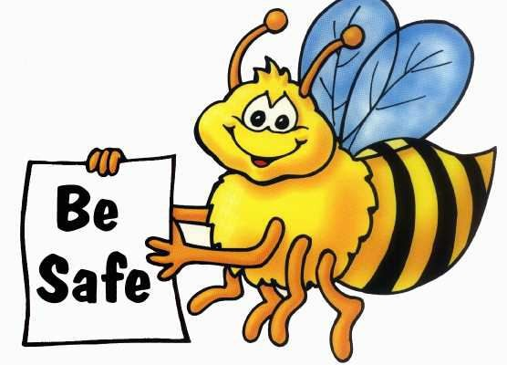

As always thank you for all your support. You know where we are if you need anything, if we can help we will.

