Christmas Plans

Let’s be honest, 2020 has been a bit of a shocker and your children and all of us deserve some fun. There are certain ‘rites of passage’ that will not be able to occur so we are going to try and fill some of the gaps for our families. The first step was monthly Birthday Parties.

And to Start
On 30th November the children will all make an Advent Calendar to bring home and use to begin their Countdown to Christmas! Please hang it up and use it with them.

Pantomine
The King’s Theatre have offered an amazing opportunity to buy access to a digital stream of their Dick Whittington Pantomine for five days, week beginning 14th December 2020 between 10am-4pm. We have purchased this
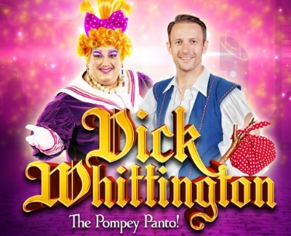
for £300. We can watch it in our Year Group Bubbles, in the Hall with juice and popcorn.

Christmas Week
This year we have decided to dedicate the last week as a Christmas Project Week. The children will still undertake their usual learning but much of it will have a Christmas twist. This will truly get them in the Christmas mood.

Christmas Craft
Usually we would invite parents in for the afternoon to do Xmas Craft – this year we cannot. However, we will still do our Christmas Craft afternoon and send all of the children’s creations home to hang up.
Christmas Cards
A COVID Secure approach to Christmas Cards. They can come in but can’t go out out for 72 hours. From 1st December there will be a postbox in each year group. Cards can be posted on a Monday andTuesday. We will then leave them give them out on Friday.

For staff sanity please ensure you write the class name on each envelope and the name of the child it is to. You do not have to send cards, it is your choice, we will send name lists later this week to help those who do.

Christmas Dinner
Christmas Dinner will be on Tuesday 15th December. The children make party hats and place mats in the morning. This year we are going to try Xmas Buffet Boxes – a letter will come out shortly with more information.

The Man Himself
We have thought long and hard, spoken to the man in the red suit and have figured out a way for a COVID secure visit. Ssshhhh, don’t tell the kids! This will hopefully help with the fact that they cannot visit him in town as we are sure you usually would. We are hoping he will bring a little gift for each of them too.

QA Hospital
We have been asked if we would like to help decorate QA to raise some Christmas cheer. So this week the children will do some early Christmas craft but their creations will be sent to QA. We will get some photos to share on the Facebook page.

Christmas Parties
There will of course be Christmas parties in the last week. These will also double up as birthday parties for those with December birthdays.

Speaking of Birthday parties. The first ones are now planned and I have been and raided the party aisle in Poundland. We are also going to give each child a small gift, the children are making birthday cards and there will be fairy cakes and squash. If we can find a way to do it we will take some photos but because of data protection I have to be careful how they are shared. I am currently looking at this and will get back to you.

Christmas Nativity
Usually we would put together a Nativity for the whole school which we would perform over a number of days for you to come and see. Again we cannot do this.

So, a COVID secure Nativity it is! This year we will do a Nativity in each year group – a short play with songs. We will record these and upload them to Facebook for you to view. If anyone has any insight into recording software which might be useful please let me know.

These are likely to be shared at the end of the last week of school, a text will be sent so you know when.
REMINDER
School Applications!
If you have a child who will turn 4 years old between Sept 2020 - Aug 2021 you need to apply for a school place.

Similarly, all Year 2 parents need to apply for Junior School places.

DEADLINE: January 15th 2021

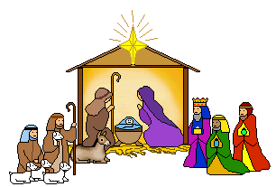

Donations
We would normally raise between £1000 and £1500 through Christmas performances and Bidbury Friends fund-raises such as cake sales and xmas fayres, which is £5-£8 per child. This year none of this is possible so we are asking for donations from you. Please only donate if you can afford it and if you donate, only donate what you can afford.

The monies raised will help pay for the Pantomine, monthly Birthday Parties, Christmas Parties, Santa gifts and much more.

Important Dates
Nov 25th pm: Y2 Birthday Party
Nov 26th pm: Y1 Birthday Party
Nov 27th pm: YR Birthday Party
Dec 14th Xmas Project Week begins
Dec 15th Xmas Dinner
Dec 18th Last day/Xmas Jumper Day

Xmas 19th Dec – 3rd Jan

Jan 4th INSET (no children)
Jan 5th All children return to school

As always thank you for all your support. You know where we are if you need anything, if we can help we will.

