Bidbury Infant

4

Well, can you believe we have almost finished our first term of this year!

Bidbury Community
Time flies when you are having fun! I would like to start with a huge thank you to you all for your Bidbury spirit and commitment. We have worked hard together to keep safe, socially distanced and ‘germ’ free whilst supporting one another throughout. As a Bidbury Community we should congratulate ourselves.

Also a huge thank you for all your support for those families affected by the fire. They were very grateful and, as far as I know, are all doing okay.

Similarly, we are astounded by the generosity you showed in donating to school for the Christmas / Birthday celebrations. We raised £858.25.

Xmas Week
As you know next week is our Christmas Week and there is much fun planned – I think the staff are more excited than the children!

Next week we have parties, pantomime, Xmas Dinner, a very special visitor, Nativity performances to record, to name but a few of the exciting things that will go on. We will whip them up into a Christmas Frenzy (and then give them to you for Christmas with love ).

COVID
COVID has not gone away and is still ruling the way we do things. You will be aware by now that we are Tier 2 which is High Alert. Schools continue as necessary and we can still run our clubs, Breakfast Club and After School Club.

IMPORTANT: Please, Please, Please continue to follow the rules and keep 2 metres apart, wear your face masks on site and keep on washing those hands. None of us want to have to self-isolate for Christmas. Some staff, and I am sure some of you, have not seen their families for months and are looking forward to finally being allowed to go and visit.

Local Award
We are all very touched by the nomination made for the school and Miss Townshend for the Havant Constituency Coronavirus Hero Award. Thank you to all those involved. We hope we have done right by our families during all of this, we are certainly trying our best to.

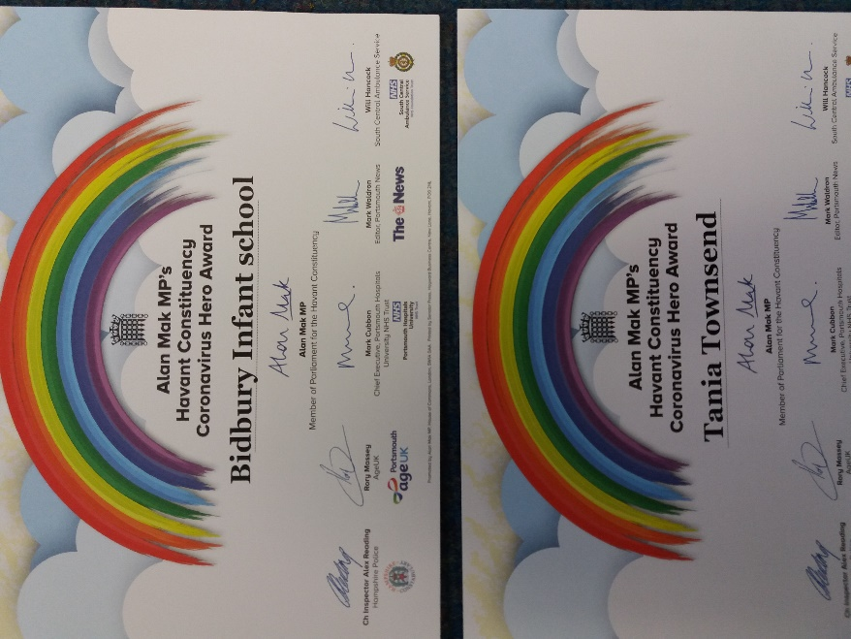
Catch-Up Curriculum
Over this term the staff and children have worked incredibly hard to try and catch-up on all the lost learning. We have made a good start and the children are making good strides.

However, we are concerned about
two weeks with no reading and writing. Therefore, staff are looking
at homework for the holiday which will keep them ticking over so we don’t lose any of the learning gained.
Watch your emails and thank you in advance for
helping us with this!!

Y2 Phonics Screening
The Year 2 staff and children are to be congratulated for some amazing phonics work. When they took the Phonics Test last week, 81% of the children passed. This is amazing in any year, and with all the work needed to fill what they have missed, it is fantastic. Well done Year 2!

Y1 Victorians
Today the Year 1 staff and children have enjoyed a Victorian School Day. All of the children looked amazing, thank you for getting involved and dressing them up.

Year R – First Term
The children in Year R have had so much to contend with – new people, new rules, new learning and new routines. They have coped so well and have worked hard. Their learning has been amazing. They are a super addition to our Bidbury Family. Well done for completing your first term in school.
We are all very proud of you!

Remote Learning
Year One and Year Two - Please sign up to Edmodo if you have not done so already. We know some people have had problems but please persevere. We will look for more effective possible alternatives over the Christmas Break.

Year R, you will continue to use
Tapestry.

Friday 18th December 2020
The children need to come to school on this day. We know there have been rumblings in the press but please ignore them – WE ARE OPEN!

This day will also be our Christmas Jumper Day. All children get to wear a Christmas themed top.

Important Dates

Dec 18th Children come to school
Christmas Jumper Day
Last day

Xmas Break 19th Dec – 3rd Jan

Jan 4th INSET (no children)
Jan 5th All children return to school

HAPPY HOLIDAYS – ENOY AND STAY SAFE

