Bidbury Infant

5

WE MADE IT! Well done to all of you, the staff and children for keeping each other safe and taking so much care of one another. The Bidbury Community Spirit is phenomenal!

Xmas Week
This week we think the children definitely enjoyed themselves, and I think the staff may well have had quite a bit of fun too. We are all exhausted and ready for a well-earned rest.

The highlight was definitely a flying visit from Santa himself, his mischievous elves (who pelted our windows with snowballs) and the thoroughly amazing Olaf!

All of us have enjoyed watching Dick Whittington, celebrating our December birthdays and making Christmas crafts.

Remote Learning
Edmodo has been a nightmare so we are switching to Office 365 for Year 1 and Year 2 children from January. Please do not worry, more information will follow shortly. We will delete the Edmodo accounts once these have been set up. Of course, we will keep you posted!
COVID I need to know if . .
If anyone of you or any child have a COVID Test which comes back positive please let me know. It is my responsibility to ensure all contacts within school are traced and informed should they need to isolate.

The school phone will NOT be manned at all in the holiday and neither will the admin email. Myself and Mrs Thumwood will also be turning our work phones off for the first time in 12 months! However, I do check my email daily and will continue to do this during the holiday. For any contact please only use this email:

advice@bidbury-inf.hants.sch.uk

IMPORTANT: Please, Please, Please continue to follow the rules and keep 2 metres apart, wear your face masks and keep on washing those hands.

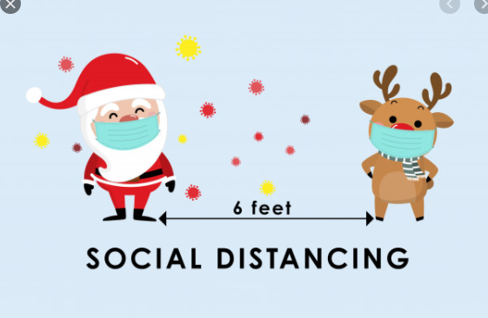
We hope you all have an amazing Christmas and wish you the best of happiness and health for 2021. Fingers crossed, we all enjoy a much better year. Take care and we look forward to seeing you on the 5th January.

Important Dates
Xmas Break 19th Dec – 3rd Jan
Jan 4th INSET (no children)
Jan 5th All children return to school

