Bidbury Infant

6

Happy New Year to you all!

Current Situation – clopen!
Clopen is a well-loved term in Headteacher circles meaning closed but open for learning whether at home or in school.

This is not the start to 2021 we wanted. As a Bidbury Community we know we’ll make the best of it and play our part in reducing the spread of the virus so we are all back where we should be sooner rather than later.

We are being told schools will be open for the children of Critical Workers and vulnerable children until at least half term. Places in school are full-time places only to ensure continuity of learning.

What Are Staff Doing
There has been a bit of negative media towards school staff over the last few weeks. Let me reassure you all Bidbury staff are in school either teaching children, producing remote learning, marking and feeding back on learning and/or continuing with strategic work.

Remote Learning
For all children not attending school in person we are providing remote learning to do at home. There is an expectation this time around that this will be completed. If work is not completed we will be liaising with parents.

Each year group is producing a timetable for the week with links to the lessons and activities to be completed. Timings for this are approximate and in total should take 3-4 hours a day.

Home and School Link Up
Hopefully soon we will have completed the set-up of Office 365 for the children. As soon as it is ready we will email your child’s login details and password.

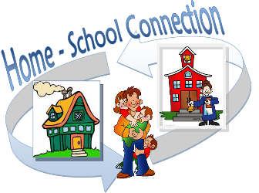

Office 365 has a Teams facility which works the same as Zoom. The plan is that we will send a link with a time on the weekly planning for each day to have some face to face time with the class and an adult from the year group. We will start small by reading stories and so on.

We can then fine tune this to small groups so we can do activities together linked to the week’s learning.

Feeding Back to Children
Office 365 will also be used for you to send the children’s work for us to see. Adults from the year group will then look through the work and give the children feedback on the learning they have done.

Reading: Book Bands
Please keep up with the children’s reading. The Oxford Owls site is good and you have access to colour banded books which are the same as those in school.

https://www.oxfordowl.co.uk/for-home/find-a-book/library-page/

Scroll down the page to ‘Levels’, click and select ‘Book Band’ and the colour levels will come up for you to choose from.

Reading: Libraries
Kid’s Zone
Hampshire Libraries have set up a new Kid’s Zone. Take a look there is some great stuff on there.
https://www.hants.gov.uk/librariesandarchives/kids-zone
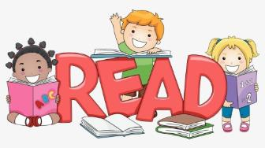
Winter Reading Challenge
Sign-up online and read or listen to any four books by Saturday 27 February. This can include books you read or listen to together, bedtime stories, non-fiction books, ebooks and audiobooks.
https://www.hants.gov.uk/librariesandarchives/kids-zone/take-part

Ready Reads
The library select books and you collect them. This is a service they introduced when libraries were not able to open as normal last time. Their teams handpick books, according to your preferences, for you to collect from your local library.
https://www.hants.gov.uk/librariesandarchives/library/services/ready-reads

COVID I need to know if . .
If you or any child have a COVID Test which comes back positive please let me know. It is my responsibility to ensure all contacts within school are traced and informed should they need to isolate.

The Admin Team are in the School Office so we can be contacted by phone or by email. Please use adminoffice@bidbury-inf.hants.sch.uk The advice email remains open too: advice@bidbury-inf.hants.sch.uk

IMPORTANT: Please, Please, Please continue to follow the rules and keep 2 metres apart, wear your face masks and keep on washing those hands.

Important Dates

Everything’s on hold for now!

Half Term: 15th Feb – 19th Feb

Start of Spring 2: Mon 22nd Feb

Easter holiday: 2nd April – 16th April

Start of Summer 1: Mon 19th April

