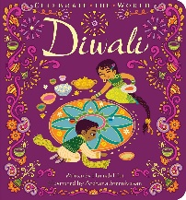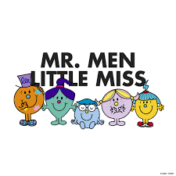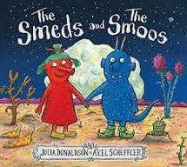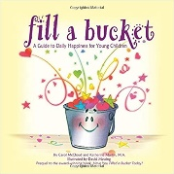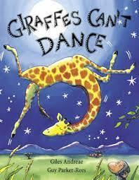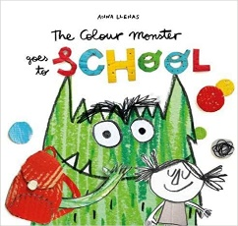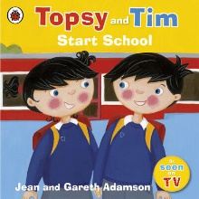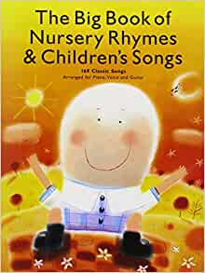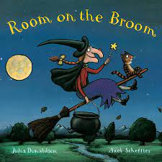

**Who are we?**

Literacy

* Hearing sounds in the environment
* Exploring sounds-rhyme and alliteration
* Sing and join in with nursery rhymes
* Listening and joining in with stories
* Mark making

Personal and Social

* Express own feelings eg sad, happy
* Join in with school routines
* Settling in and making new friends

Numeracy

* Joining in and singing number songs
* Recognize numbers significant to them
* Counting and comparing

Celebrations

* Diwali
* Halloween
* Star of the day
* Birthdays
* Yom Kippur

Physical development

* Use one handed tools with good control
* Can negotiate space and move with good control

Expressive Art and design

* Self-portraits
* Safety use with materials and tools eg- scissors
* Colour mixing