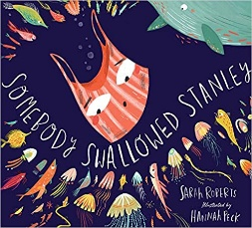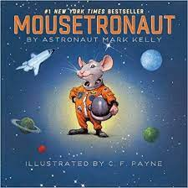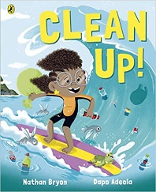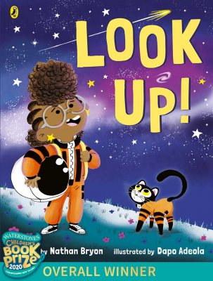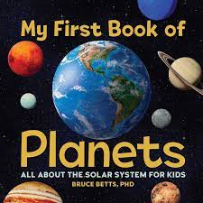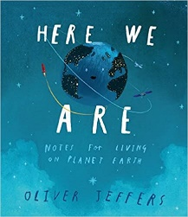

Personal and Social

* Express own feelings eg sad, happy, tired, worried, angry
* Communicate own needs to a familiar adult
* Building relationships

Numeracy

* Recognise numbers significant to them
* Recognize and comparing number 1,2, 3, 4 and 5
* Exploring 2D and 3D shapes
* 1 more and 1 less
* Exploring time in simple terms eg night and day

Understanding of the World

* Local area- Mr Men adventures
* Solar system
* How to take care of our planet
* Where would you go on a space rocket?

Literacy

* Exploring sounds-rhyme and alliteration
* Make up own nursery rhymes
* Listening and joining in with stories
* Can identify sounds in words
* Has a go at writing own name
* Can speak about characters in stories

Physical development

* Use one handed tools with good control
* Developing a pencil grip
* Why is exercise important?

Expressive Art and design

* use materials and tools eg- scissors
* Junk modelling
* Colour mixing

**Where are we?**