English

We will be reading ‘The Perfect Fit’ and using this as a stimulus to practise writing skills including name writing and short words and labels.

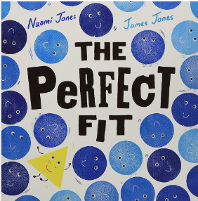
Maths

Our maths learning will focus on number and place value, building on our existing understanding of the number system. We will use number lines to secure our understanding of more/less and we will begin to count in 10s.

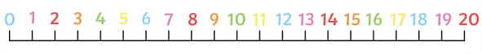
PSHE

Our unit ‘Me and My Relationships’ helps us to establish classroom rules as well as discussing feelings and friendships.



Incredible Me!
Year 1 – Autumn 1
Geography

We will learn what a ‘geographer’ is and explore where we fit in the world. We will use google earth to zoom in on the UK and England.

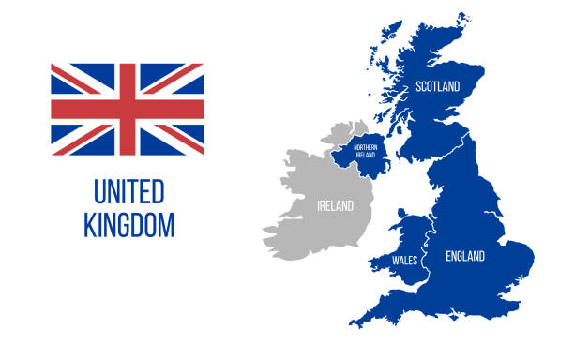

`
PE

This half term we will be developing personal skills involving coordination through footwork and static balance on one leg.
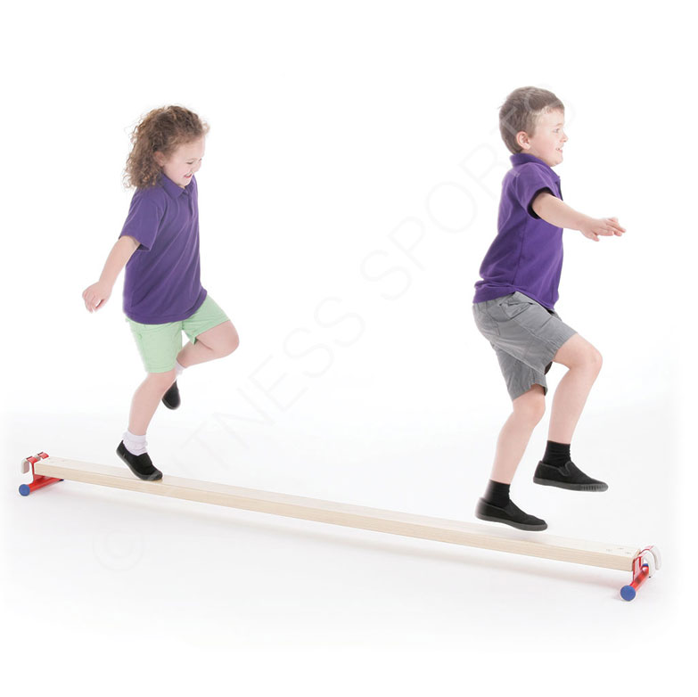

Music

We will be introducing the terms ‘pulse’ and ‘rhythm’ through clapping and singing games.


