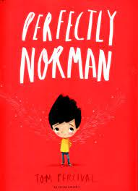

**Language to explore:** respect, compromise, mistakes, resilience, tolerance, pride, independence, regulation

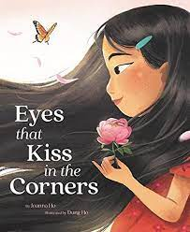

**Milestone 1:**

* Children are building strong relationships with adults and some other children in the setting.
* They can talk about who they can go to in school if they need help.
* Children can tell others their needs and wants.

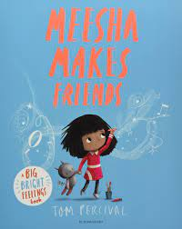

**Settle in and become a confident learner**

**Milestone 3**

* Children can show their work to their friends.
* They can talk with pride about what they have done
* Children can speak about mistakes in a positive way and they understand that mistakes are a part of learning.
* Children can regulate their behaviours when needed

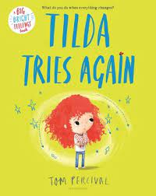

**Milestone 2:**

* Children are playing and interacting with their friends, listening to each other and adapting to what each other wants/needs.
* They are using language to negotiate and extend their play.
* Children are more independent in tasks and are beginning to use the 5 B’s to help figure things out Brain, board, book, buddy, Boss

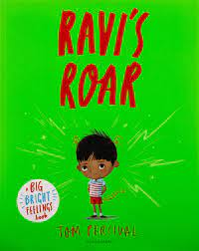

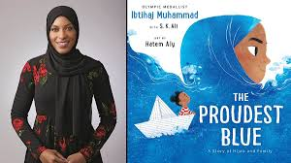

**Final Milestone**

Children can persevere when things get tricky and show resilience

They can talk about what they can do well and what they might be able to get better at.

Children can talk about our school values and how they demonstrate these values.