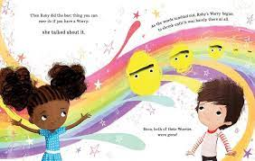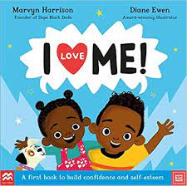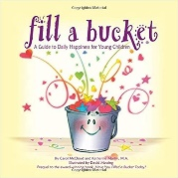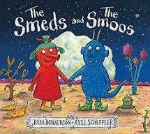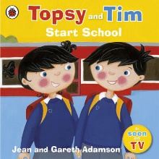 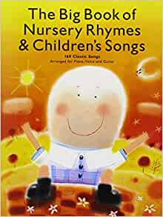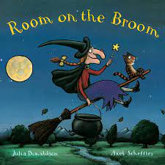

**Numeracy**

* Joining in and singing number songs
* Recognise numbers significant to them
* Counting and comparing
* Sorting in to sets
* Recognise and continuing repeating patterns
* Speak about familiar 2d and 3d shapes

**Personal and Social**

* Express own feelings eg sad, happy, angry, worried
* Join in with school routines
* Settling in and making new friends
* Zones of Regulation – How to regulate our emotions
* Our School values – focusing on respect and independence

**Literacy**

* Hearing sounds in the environment – sound walks
* Exploring sounds-rhyme and alliteration: rhyming and syllable clapping with their names
* Sing and join in with nursery rhymes
* Listening and joining in with stories
* Mark making on paper

**Physical development**

* Use one handed tools with good control
* Can negotiate space and move with good control
* ABC of movement focus on A for agility – moving at different speeds and in a range of directions

**Who We Are**

**Celebrations**

* Halloween
* Gem of the day
* Birthdays
* Yom Kippur

**Expressive Art and design**

* Self-portraits
* Safety use with materials and tools eg- scissors
* Colour mixing
* Linking colour to music and how we feel